Overall Rating Comparison
Nykaa vs. Tira vs. Sephora

PARAMETER | NYKAA | TIRA | SEPHORA
Learnability | 8/10 | 9/10 | 9/10
Usability | 8/10 | 9/10 | 9/10
Consistency | 9/10 | 8/10 | 9/10
Use of Metaphors | 9/10 | 9/10 | 9/10
Navigation Structure | 8/10 | 9/10 | 9/10
Visual Hierarchy | 8/10 | 9./10 | 9/10
Accessibility | 8/10 | 9/10 | 9/10
Responsiveness | 8/10 | 9/10 | 9/10
Efficiency of Interaction | 8/10 | 9/10 | 9/10
Feedback & System Status | 9/10 | 9/10 | 9/10
Error Prevention & Recovery | 8/10 | 9/10 | 9/10
Aesthetic & Minimalist Design | 8/10 | 10/10 | 9/10
Content Readability | 8/10 | 9/10 | 9/10
Search & Discoverability | 9/10 | 9/10 | 10/10
Performance Perception | 8/10 | 10/10 | 9/10
Trust & Credibility | 9/10 | 9/10 | 9/10
Personalization | 9/10 | 10/10 | 10/10
User Satisfaction | 9/10 | 9/10 | 9/10

LEARNABILITY

The ease with which a new user can understand and start using the interface.

Evaluation
Platform | Rating | Description
Nykaa | 8/10 | - Search bar is easy to locate.  - Categories are clearly labelled.  - Familiar shopping layout makes navigation simple.  - Multiple promotional banners make the homepage feel slightly crowded.  - Important shopping sections require some scrolling.
Tira | 9/10 | - Clean and organised homepage layout.  - Search bar and categories are easy to identify.  - Good spacing improves readability.  - Minimal visual clutter compared to Nykaa.  - Simple navigation makes the interface easy to learn.

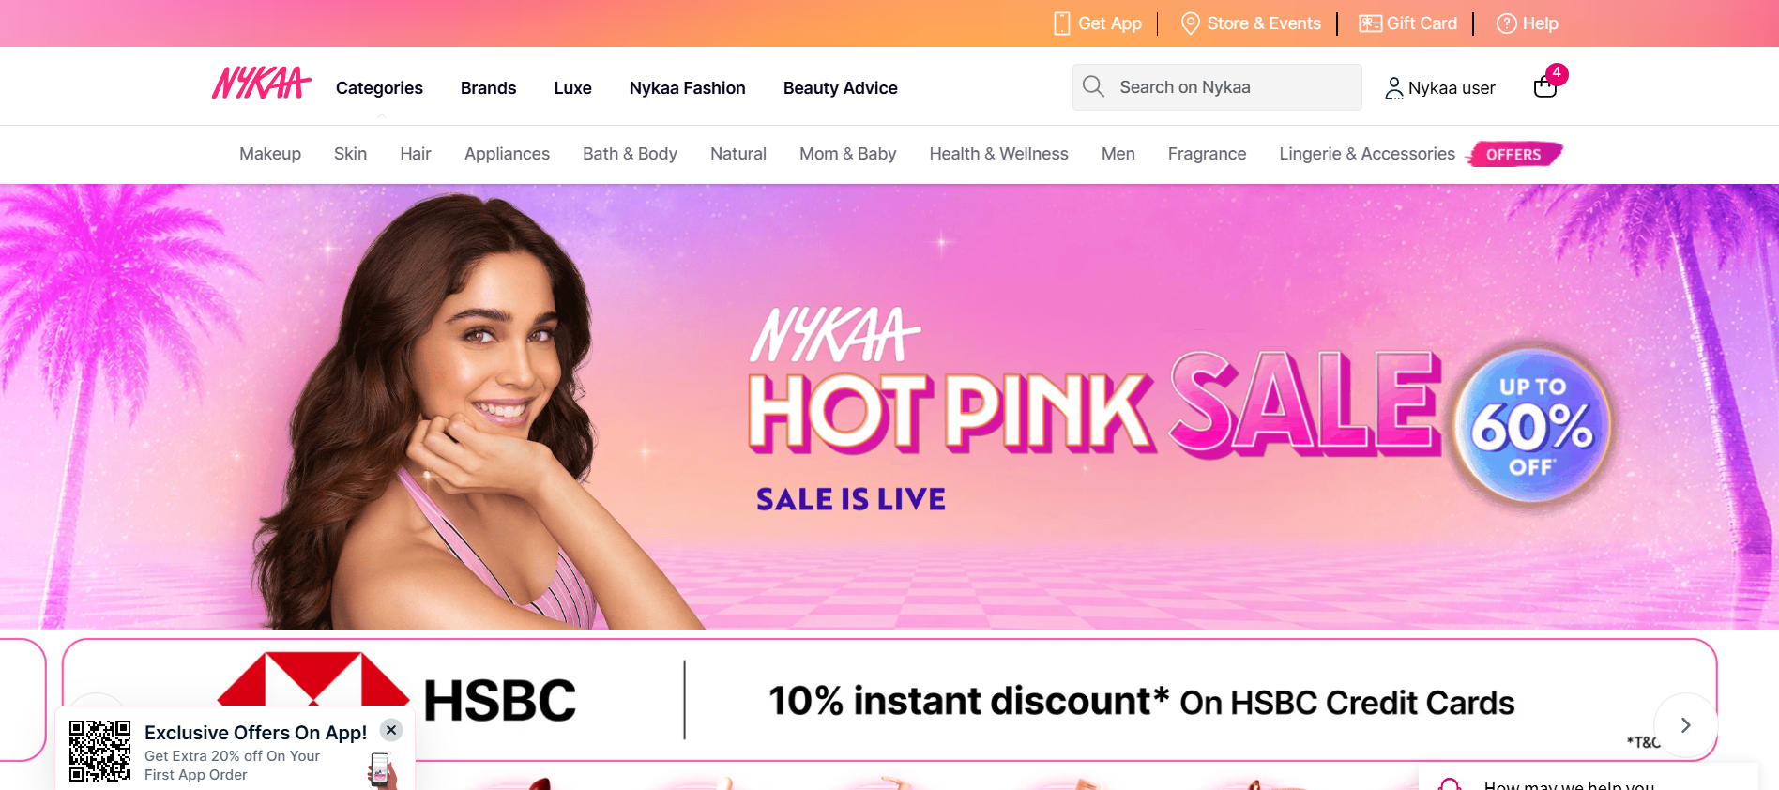
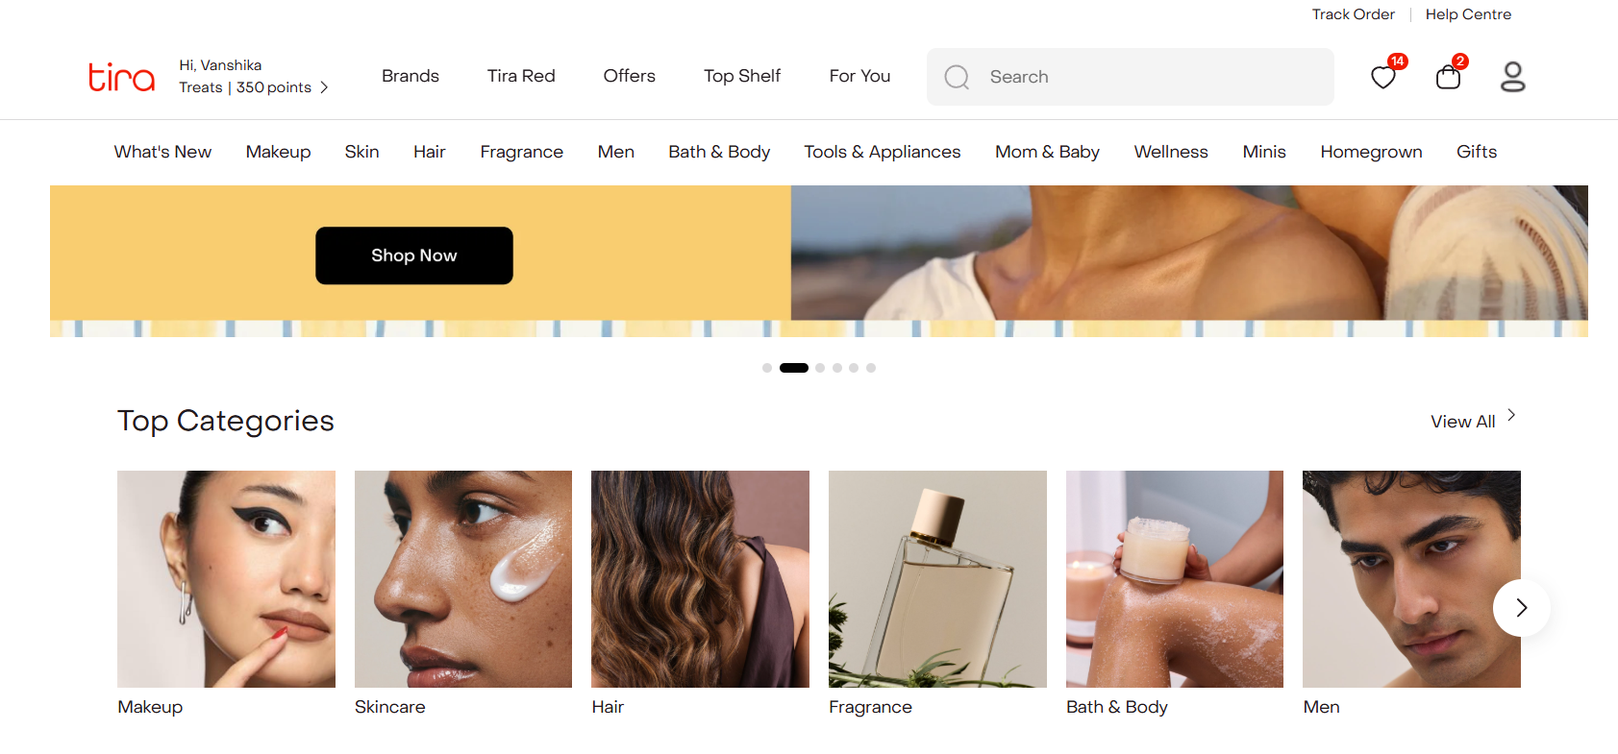

USABILITY

The ease with which users can complete tasks efficiently and comfortably.

Evaluation
Platform | Rating | Description
Nykaa | 8/10 | - Product categories are easy to browse.  - Filters and sorting options simplify product selection.  - Product pages provide detailed information and reviews.  - Wishlist and cart are easily accessible.  - Some screens feel busy due to frequent promotional content.
Tira | 9/10 | - Clean interface makes everyday tasks straightforward.  - Filters, categories and search are easy to use.  - Product information is presented in an organised manner.  - Navigation between pages feels smooth and consistent.  - Minimal clutter improves the overall shopping experience.

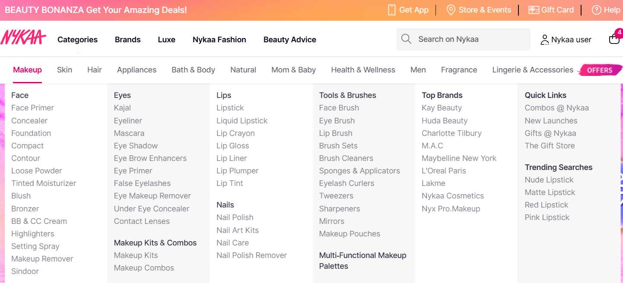

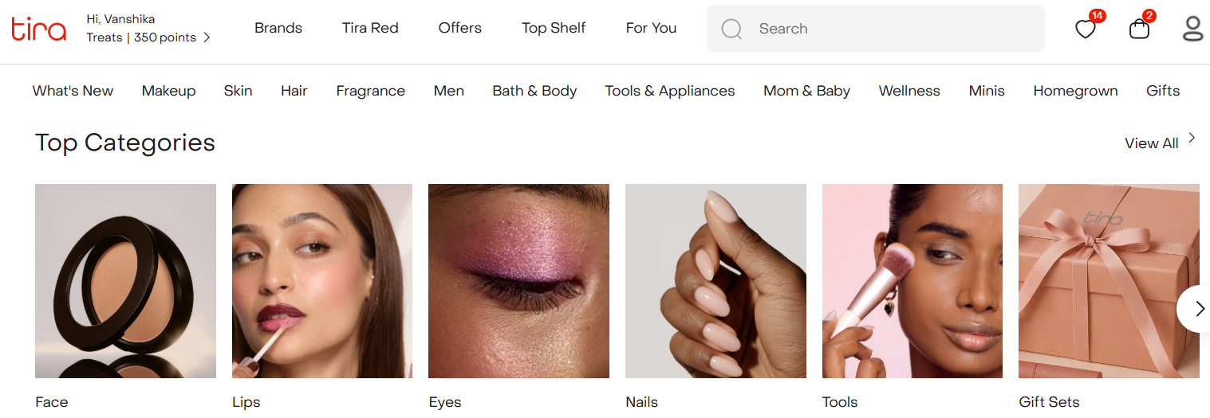

CONSISTENCY

Consistency refers to maintaining a uniform design, layout and interaction throughout the interface.

Platform | Rating | Description
Nykaa | 9/10 | - Bottom navigation remains consistent across major screens.  - Icons, fonts and colours follow a uniform design language.  - Product cards maintain a similar layout throughout browsing.  - 'Add to Bag' and Wishlist buttons appear in familiar positions.  - Promotional banners occasionally vary in style.
Tira | 9/10 | - Navigation remains consistent across different pages.  - Typography, icons and spacing follow a uniform style.  - Product listing and detail pages have a similar structure.  - Some promotional cards differ slightly in design.  - Overall interface remains organised and predictable.

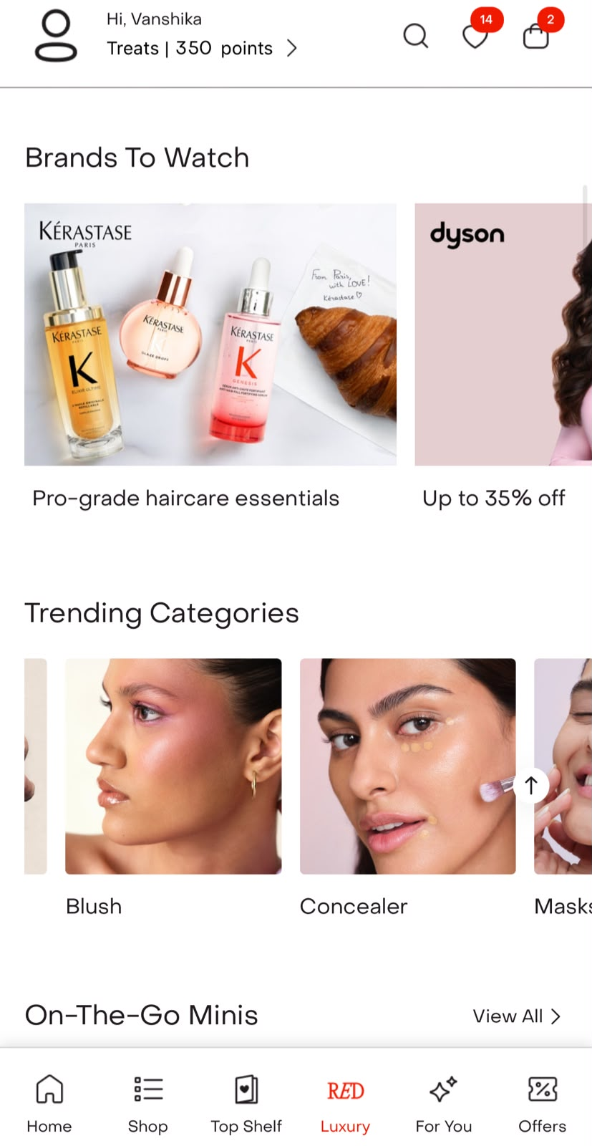

USE OF METAPHORS
Use of metaphors refers to familiar icons, symbols and design elements that help users understand actions without needing explanations.
Evaluation
Platform | Rating | Description
Nykaa | 9/10 | - Shopping bag, heart and profile icons follow common e-commerce conventions.  - Search icon and filter icon are easy to recognise.  - Star ratings clearly indicate product reviews.  - Category images help users identify products quickly.  - Most icons are self-explanatory and require little learning.
Tira | 9/10 | - Uses familiar shopping, wishlist and profile icons.  - Clean icon design makes actions easy to understand.  - Filters and sorting use standard symbols.  - Brand and category images support quick recognition.  - Consistent iconography reduces confusion while browsing.

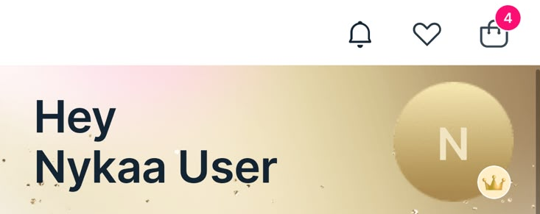



GOLDEN RULES

1. Strive for Consistency
Nykaa performs strongly with consistent layout and branding across pages, while Sephora matches closely and Tira/Purplle show minor inconsistencies.

2. Seek Universal Usability
Nykaa offers good usability for most users, but Tira slightly improves with cleaner design, while Purplle is less refined.

3. Offer Informative Feedback
Nykaa provides clear feedback through confirmations and loading indicators, with other platforms performing similarly.

4. Design Dialogs to Yield Closure
Nykaa performs well with clear order confirmations and task completion flows, comparable to Sephora and Tira.

5. Prevent Errors
Nykaa effectively prevents errors through prompts and confirmations, with similar support from Tira and Sephora.

6. Permit Easy Reversal of Actions
Nykaa performs best here with easy cart edits and cancellation options, while others offer similar but slightly less flexible controls.

7. Keep Users in Control
Nykaa keeps users in control through clear navigation and filtering options, with Tira and Sephora offering similar experiences.

8. Reduce Short-Term Memory Load
Nykaa performs moderately well, but Tira stands out with a cleaner UI that reduces cognitive load more effectively.

